JEOL IT800 SEM

Operating Procedure

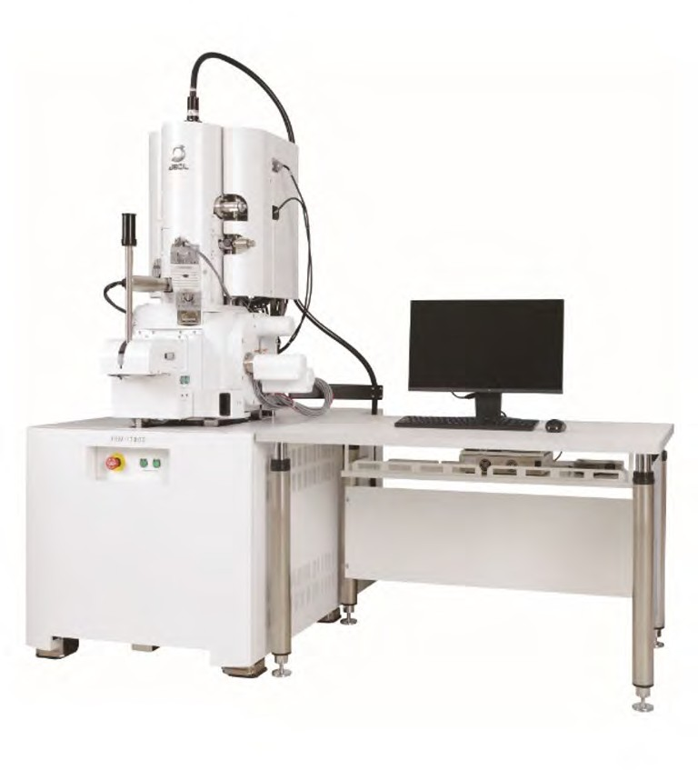

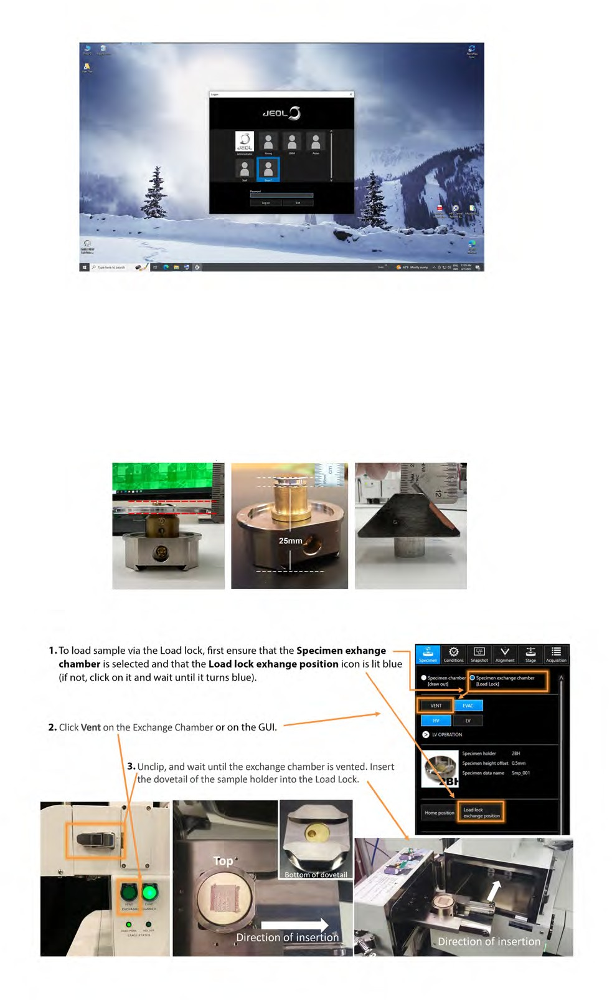
Log into the software.

Click on your login name and enter your password. If the login window is closed, double-click on SEM Center.

Preparing your sample.
If the specimen protrudes from the top of the specimen holder, measure from the top of the sample holder to the highest point on your sample. This will be
the Specimen Height Oﬀset you record in the specimen holder settings window.

Loading a sample into the load lock.

  - Attach the clip to close the Load Lock and press
Evac on the Exchange Chamber or click Evac in
Navigation Camera Settings

the GUI. The Stage Navigation Camera will automatically take an image.

  - Before loading the sample into the chamber, check the Stage Navigation image.

  - If the automatic image is too dark or too bright, it can be re-taken. Click the Wrench to change settings (choose Dim, Normal, or Bright).
Then, click the Camera icon to retake the photo.
If the camera is not in view use the slider bar to scroll down.
Check to show the current position

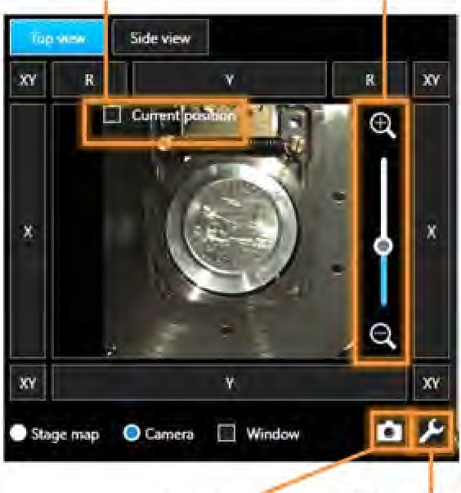
Click to retake
the photo
Click to zoom in
and out

Click to change
photo settings

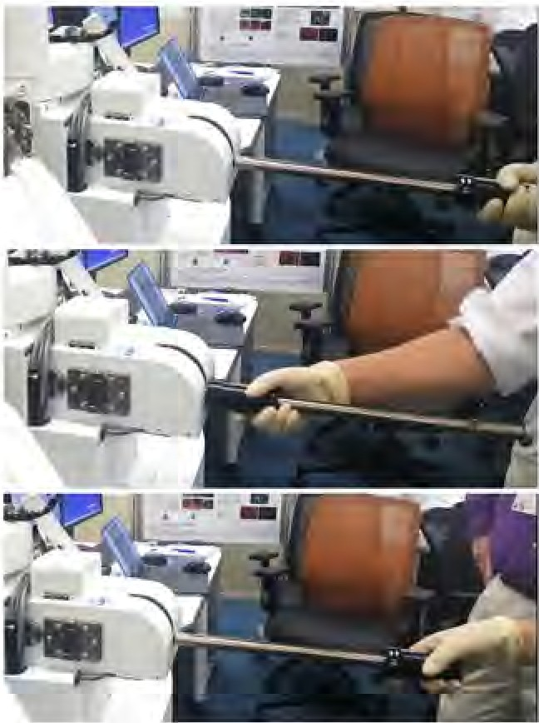
Once the Evac button is solid green you can transfer your sample Into the chamber.

    - Grip the rod by the handle and lower the rod until it is completely horizontal.
    - Pull out the handle towards you and turn it clockwise to 'IN/OUT only'.

    - Insert the rod fully, so that the sample holder is on the stage. The sample holder
window will pop up when fully
inserted.

    - Pull the rod out all the way until it sto11s.
    - Turn the handle counterclockwise to'UP/DOWN only'.
    - Raise the rod until it is back in its original vertical position.

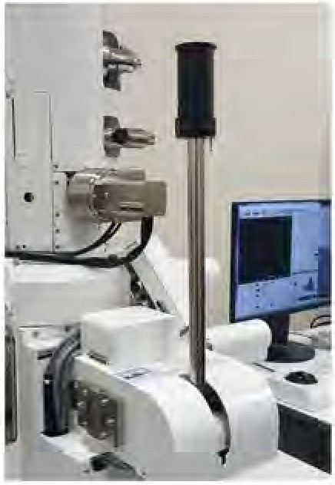
When the loadarm is fully inserted into the chamber, the Specimen Holder Senttings window pops up.
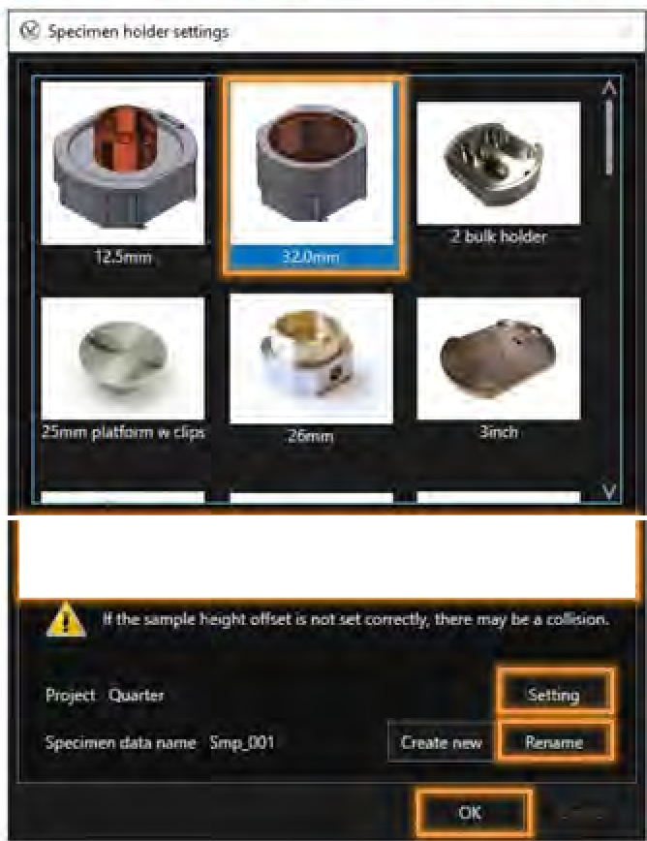
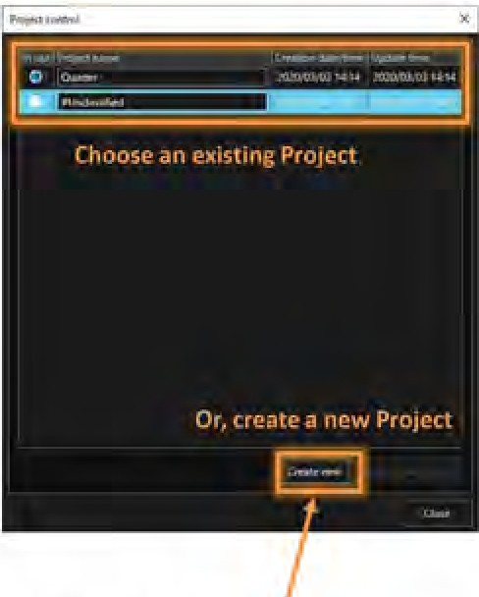
Make sure you retract the loadarm and set your height offset (if you have one) before clicking 'OK'!
<;..,.,r:1,-t1••.-.c,h" ".,.• IL....-P'
<
>

      - Choose the correct speclmen holder

      - Move the slider to the correct Specimen Height
Offset value measured
previously.

      - Click Setting to open the Project Control window, to choose
-an existing Project or create a new Project.
.,._.Add/Rename a Specimen name

      - Click OK when done

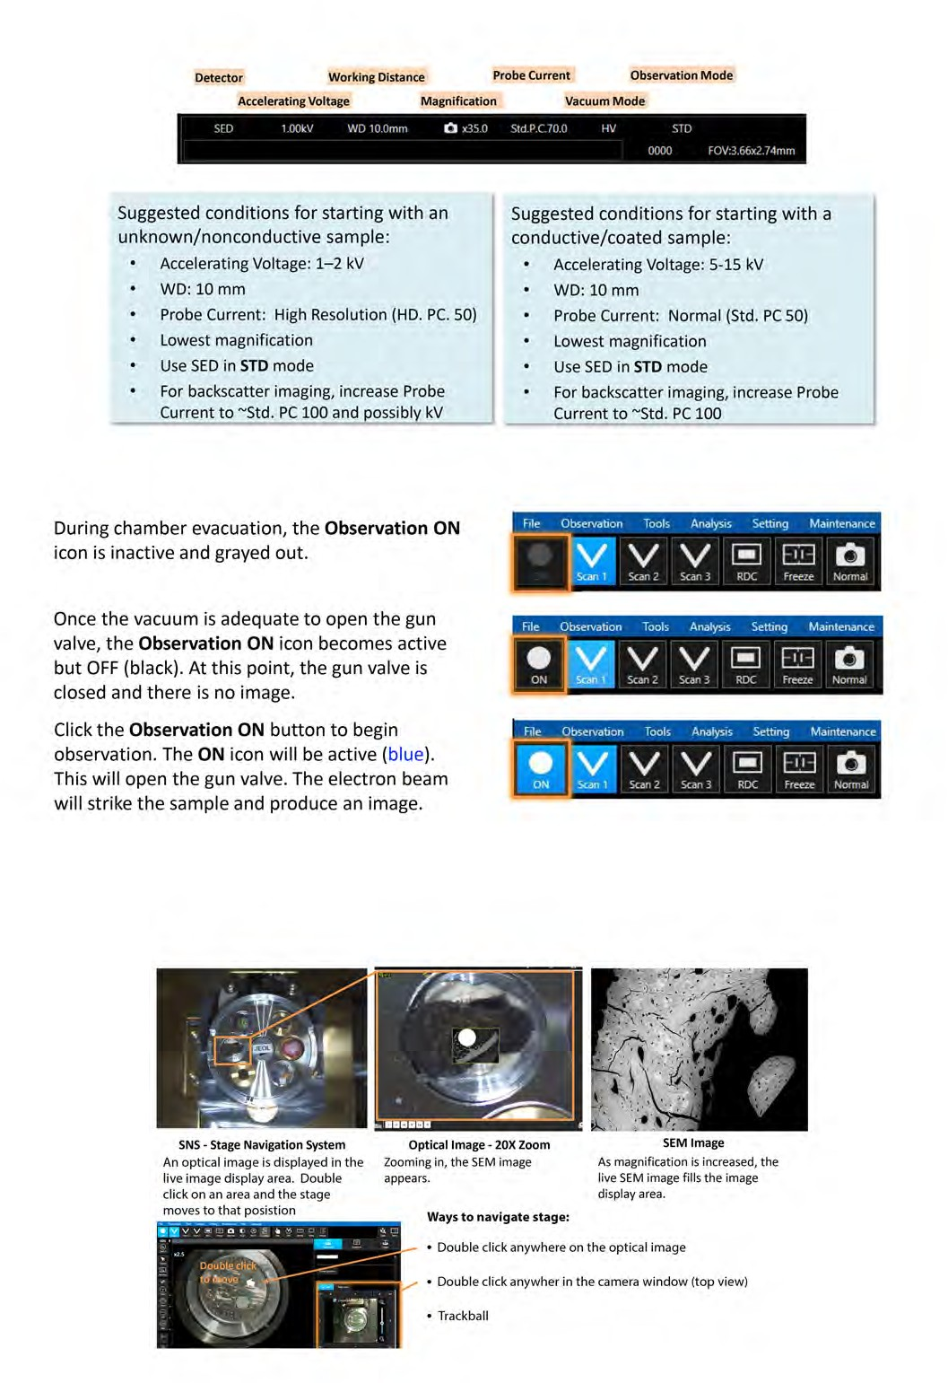
Operating conditions.
Current viewing conditions are shown at the bottom of the display. Each area is active. Click the area to manually change these conditions.

Turning on/off observation.

- Sample navigation with Zeromag
  - After turning on the beam, zoom out to see the SEM image on top of the optical image. An
optical image of your sample holder is indexed to the stage coordinates and linked with the SEM image.
  - Move to your area of interest.

Controls overview.
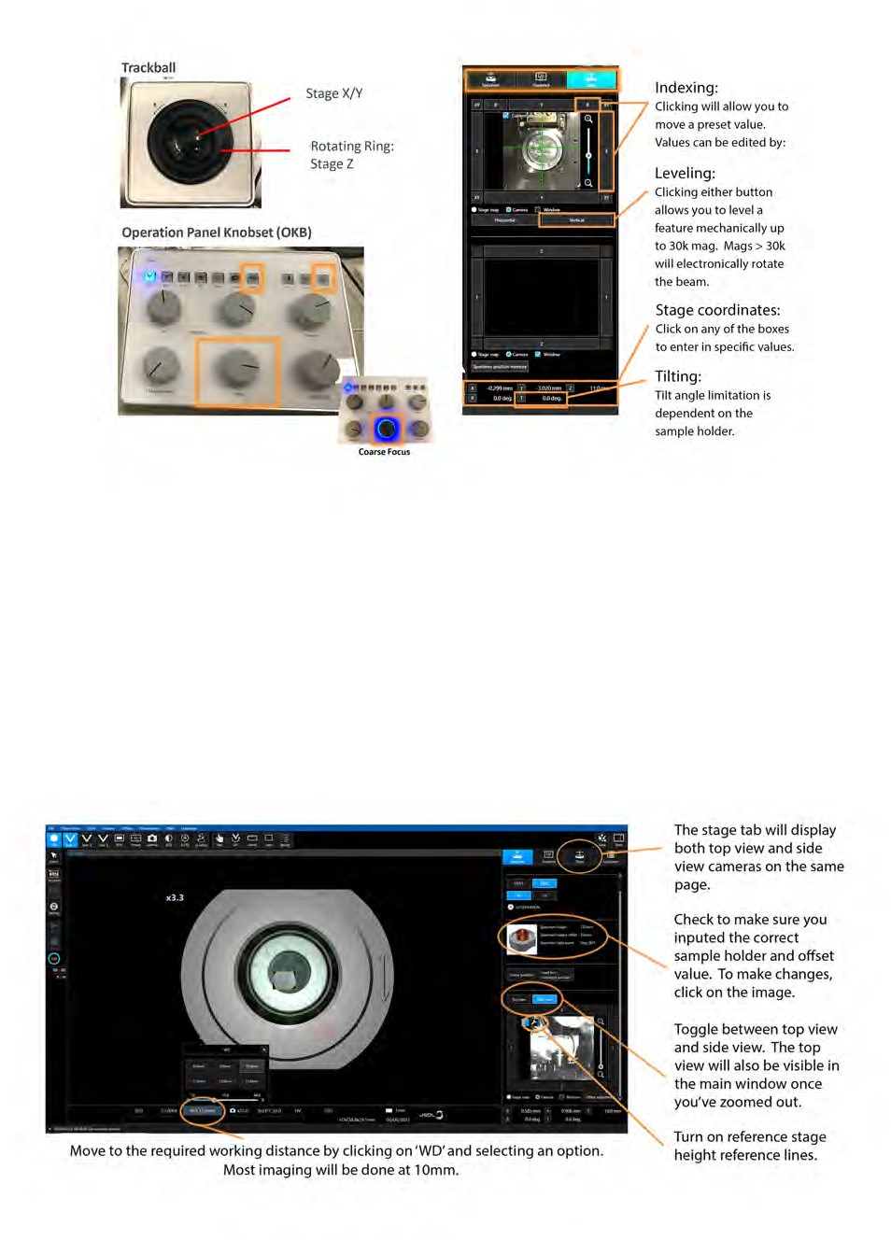
The instrument can be controlled through hardware and software. The Focus, Contrast, and Brightness knobs on the Operation Panel Knobset have coarse and fine settings. Press down on a knob to toggle between coarse and fine adjustment. A blue ring will light up around the knob if the setting is coarse.

Moving the stage up
  - Before moving the stage, you MUST ensure the Side view camera option is selected in the camera window or click on the Stage tab and make sure the side view camera is in view. You MUST also make sure the stage height reerence lines are displayed. If they’re not, click the wrench icon and turn them on.
  - To move the stage up, click the WD drop down and select 10mm. Make sure you have correctly entered any oﬀset you may have. A window will pop up prompting you to click ok. Once you click OK, the stage will start moving up. If your sample/sample holder crosses over the 10mm reference line, click Cancel on the movement window or touch the trackball. This will immediately stop any stage movement. Adjust your oﬀset and then select 10mm again.

- Resolving an image.
  - Once the stage has reached your selected WD you should initially focus the image using the Z focus.

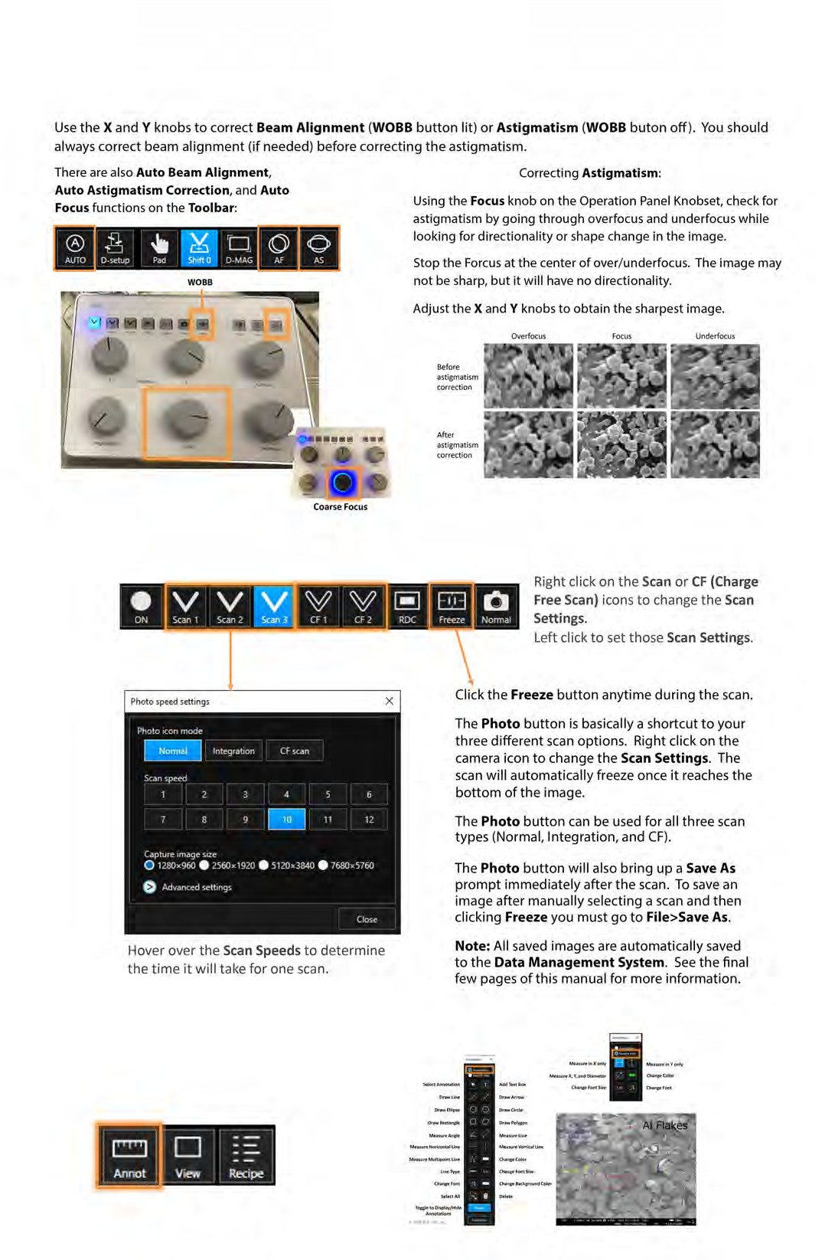
To do this, rotate the ring around the trackball clockwise/counterclockwise until the image comes into focus. This will set your selected WD to the surface of your sample.
  - From here you can use the Focus knob for finer adjustments.

Taking an image, scan settings and saving.

- Measurement and annotation.
To take a measurement click the
Annot button on the Toolbar.

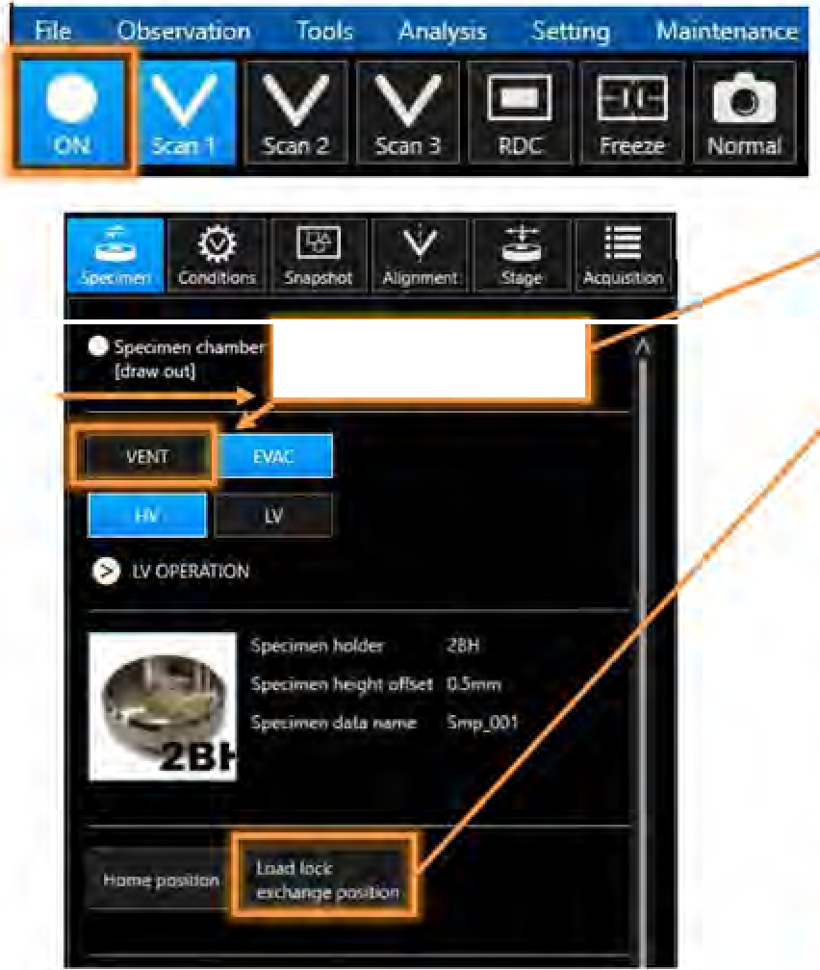
Once you are done imaging click the Observation On button to turn off the beam. The blue area should turn to black.
Q<;p,r,,.,r,,r,.., llCh.l."Cl"'<h.itm r
[, 0.1<11 j

Make sure the Specimen exchange chamber is selected
if you are unloading through the load lock.
Click the Load lock exchange position icon and wait until it turns blue. It is now safe to unload your sample into
the load lock.
Follow the instructions for loading/unloading on page
Once you have retracted the load arm and returned It to it's home position you can press the Vent button on the load lock chamber.
Unclasp the clamp and remove your sample. Close the load lock and press Evac.
Go to File>Log off

DO NOT EXIT!

1ED wr,1oc..lmn1 O,_)fJ 5tdP(_/01l HV .1l)
!(J(J V

()O(J() I ()V) Ot)X 14mm

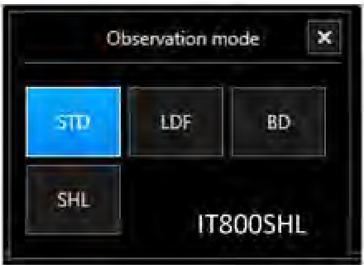
STD (Standard):
Standard mode for imaging with the SEO, BED, LVBED, or LVSED.

LDF (Large Depth of Field):
Turns off the objective lens and can be used when imaging very tall samples to get a large-depth-of-field image, to get an undistorted low-magnification image, or to get a lower magnification image at short WD.
BD (Beam Deceleration):
Appliesa bias to the sample stage for high-resolution imaging and/or charge balancing (bias voltage up to 5 kV on IT800SHL).
SHL (Super Hybrid Lens on ITB00SHL):
Turns the electrostatic field of the objective lens on, attracting more electrons up the column.

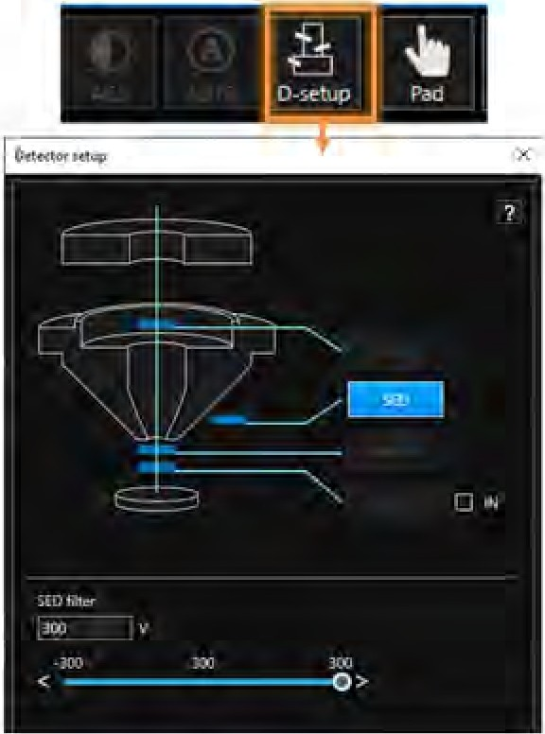
1 O0.V WD 10 Omrn O ,,'., 0 Std PC 70 0 t!V

IT8005HL De1ee10,

[ ::j ^{urn}

uED Liter
IH efff'ct

Before inserting the SBED detector you must be at a WO of 8mm or greater.
Click on the Detector name to open the Detector window.
,.Activate a detector by clicking on It.
The filter settings of the UED
detector can be changed here.
To insert a retractable detector (Option), click D-setup from the Toof bar to open the Detector Setup W!ndow.
Check IN to insert a detector. Uncheck IN to retract a detector.

Hl 10UkV WO100mrn 0)'''10 "-tdP( 100 HV '.:.10
Ut100 FOV 3 6b)(/ 14mm

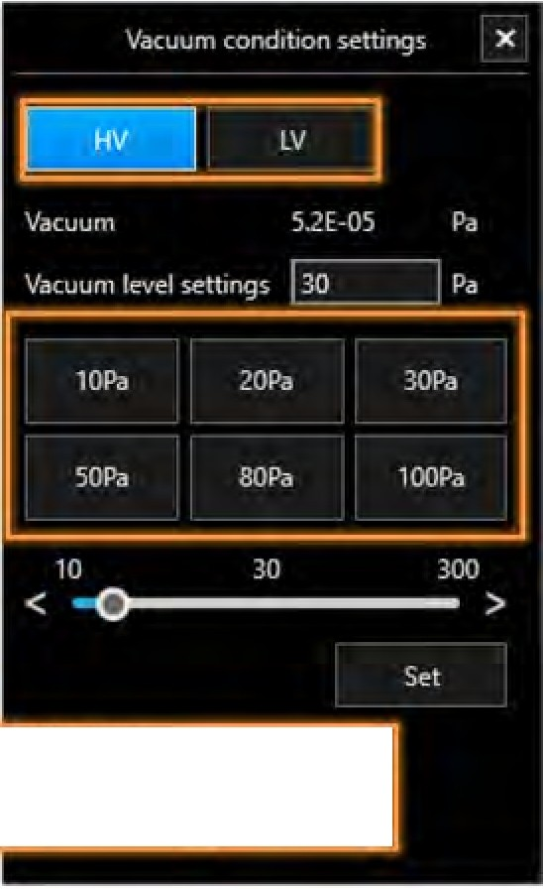
Low Vac mode mechanically inserts a detector onto the base of the pole piece. The safest way to enter Low Vac mode is to enter it before loading a sample.

LVorifice

IN
To switch from High Vacuum Mode to Low Vacuum Mode, click on HV to open the Vacuum Condition Settings window. Or click the LV button above the sample holder image.
Make sure the Specimen Height Offset is correct before proceeding!
Click LV. A pop-up window will ask to confirm the transition to low vacuum. Click OK.
Automatically, the stage moves to the insertion position, the LV orifice inserts, then the stage moves back to the original position. The observation will be active in ~2.3 minutes.
To set a different pressure, click on a preset, or type in a value or use the slider and click Set.
You MUST return to HV mode before ending your imaging session!

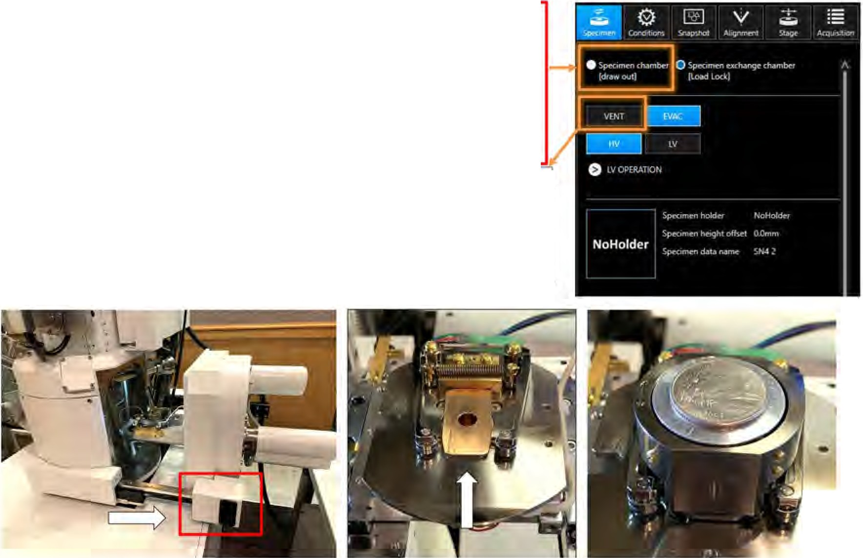
To load the specimen through the chamber door: Click Vent in the Specimen Tab. A popup window will ask if the stage should be moved to the specimen exchange position.
Click OK and wait until the system is vented.

Pull on the handles to open the chamber and slide the specimen holder onto the dovetail.
If the IT800 has a Load Lock, one can load a sample via the Chamber or Load Lock. To open the Chamber, click Specimen Chamber in the Specimen tab first. Then click Vent.
For Load Lock Specimen Exchange
instructions, proceed to Slide 1131.

A 'fl::.: : :\ ---:: :: ·,:;; ·; ":
□

>a••

•

