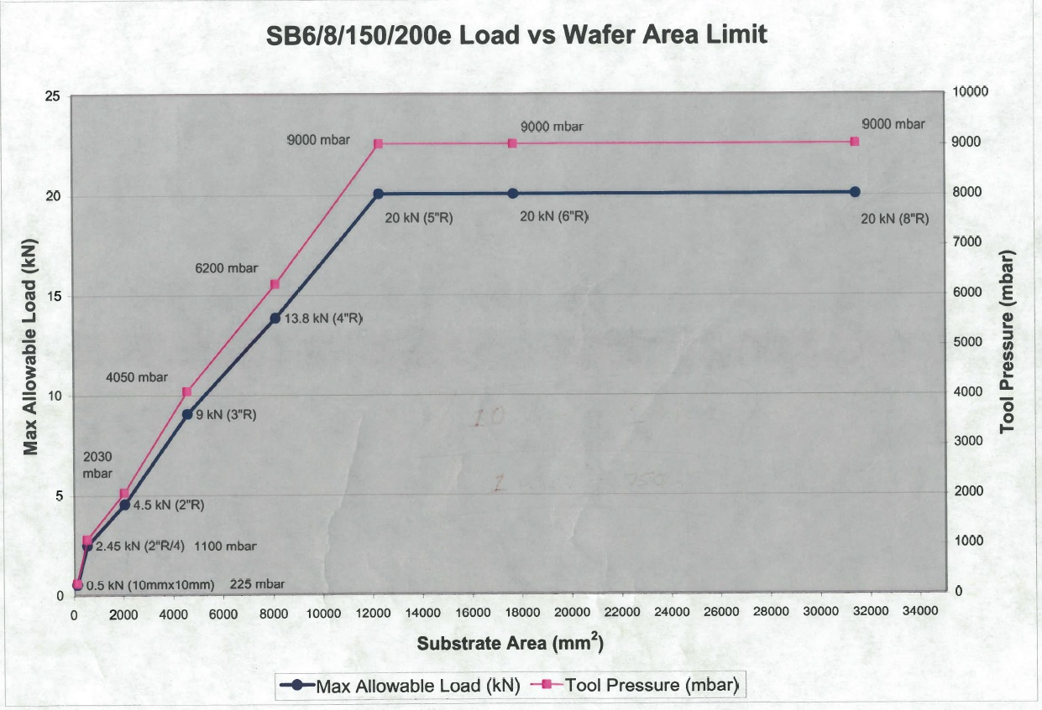
Tool Pressure Rules
Failure to follow these guidelines will not only crush your sample but can also destroy chamber components and the bonding fixture!!
Sample Size | Maximum Tool Pressure (mbar)
10 x 10 mm² | 225
1/4 of 2" Wafer | 1000
2" Wafer | 1800
3" Wafer | 3600
4" Wafer | 5500
5 - 8" Wafer | 7000

