**FIRST LAYER: BL quarter piece**

**Reticle with 4 quadrants**

These are instructions for exposing the first layer on a piece part (quarter) using the 4-quadrant reticle. The program is written in Biljana’s account [10,151]. The program name is: **QBL8**. Please follow instructions below to copy this job from Biljana’s account to your account.

* LOG IN to your account
* At the prompt sign enter **COPY**
* It will pop-up the question **From?** Type **[10,151]QBL8** and press enter

[IMPORTANT: Please type info exactly as it says, no space!]

* It will pop-up the question **To**? Type [10, your account] press enter

Once the job **QBL8** is in your account, please copy this job to a new job [for example: **ABC123** ]. For example: **COPY QBL8 ABC1213**

Use the command EDIT to make all necessary changes in the new job **ABC123.**

When designing the reticle please have this in mind:

1. Stepper is 5X reduction
2. Reticle is (5x5) inch2
3. Spot size at the wafer level is 21mm in diameter
4. The largest single square die size you can shoot ~ (14.8x14.8) mm2

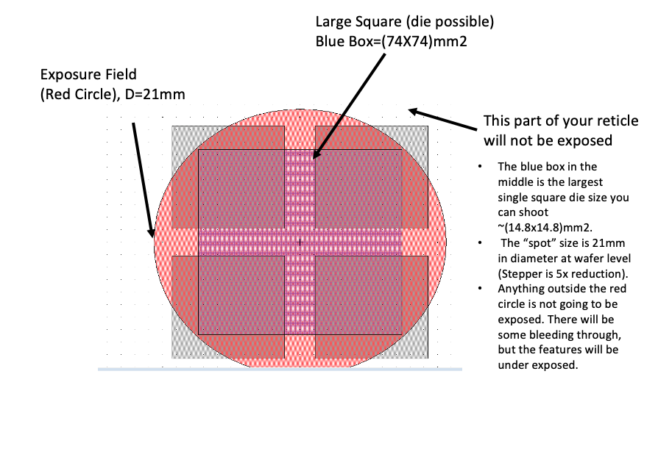

**JOB QBL8**

**: EDIT QBL8**

**JOB COMMENT:** Expose BL quarter using 4 quadr mask

**TOLERANCE:1**

**SCALE CORRECTIONS:** skip it,press ENTER (it is RETURN key on the keyboard)

**ORTHOGONALITY:** press ENTER

**LEVELER BATCH SIZE [1-25]:1**

**WAFER DIAMETER:75.0000**

**<<ARRAY PARAMETERS>>**

**STEP SIZE:**

**X: 7.9000**

**\*C-OUNT, S-PAN, OR A-LL:** press ENTER

**HOW MANY COLUMNS? 3**

**STEP SIZE:**

**Y: 7.9000**

**HOW MANY ROWS? 3**

**TRANSLATE ORIGIN:**

**X: -12.8400**

**Y: 13.4400**

**DISPLAY? (Y/*N):** N is default, press ENTER

**LAYOUT? (Y/*N):** N is default, press ENTER

**ADJUST? (Y/*N):** N is default, press ENTER

**<<ALIGNMENT PARAMETERS>>**

**STANDARD KEYS? (Y/*N):** N is default, press ENTER

**RIGHT ALIGNMENT DIE CENTER**

**R: 3**

**C: 3**

**RIGHT KEY OFFSET**

**X: 0**

**Y: 0**

**LEFT ALIGNMENT DIE CENTER**

**R: 3**

**C: 1**

**LEFT KEY OFFSET**

**X: 0**

**Y: 0**

**EPI SHIFT**

**X:**

**Y:**

**<<PASS>>**

**NAME: 1**

**PASS COMMENT:** BL Quarter_4quadr mask_1st layer

**USE LOCAL ALIGNMENT? (Y/*N)**

**EXPOSURE(SEC): 0.390**

**EXPOSURE SCALE FACTOR [0 ->2]: 1.000**

**FOCUS OFFSET [-50 -> +50]: 0**

**MICROSCOPE FOCUS OFFSET [-2000 - > +2000]: 0**

**ENABLE MATCH? (Y/*N):**

**PASS SHIFT:**

**X=+8.8000**

**Y=-8.8000**

**RETICLE BAR CODE: NONE**

**MASKING APERTURE SETTING:**

**XL: 50**

**XR:10**

**YF: 50**

**YR: 10**

**RETICLE ALIGNMENT OFFSET (MICRONS):**

**XL:**

**XR:**

**Y:**

**RETICLE ALIGNMENT MARK PHASE (P, *N, X):** N is default, press ENTER

**RETICLE TRANSMISSION % [0 – 300]:**

**A-RRAY OR P-LUG: A**

**DROPOUTS:** Type “D” to display dice to be exposed

**R:** enter row you want to drop

**C:** enter column you want to drop

**<<END PASS SET-UP >>**

**SAVE PASS? (*Y/N):**

**<< PASS >>**

**NAME (<CR> to exit pass setup):** press ENTER

**WRITE TO DISK? (*Y/N)**

**PURGED EDITED FILES? (*Y/N)**

**EXPLANATION of the job QBL8:**

**TOLERANCE:1**

* Tolerance is always 1. This is the time given to the stage to go through motion and stop.

**LEVELER BATCH SIZE [1-25]: 1**

* 1 (wafers and big samples can be leveled)
* -1 (samples < ¼ of 2” cannot be leveled)

**WAFER DIAMETER:75.0000**

* This is the diameter of the area being exposed. My substrate is ¼ of a 4inch wafer, so the diameter is big (72mm). You do not have to enter the exact diameter of the area being exposed. Close enough is OK.

**<<ARRAY PARAMETERS>>**

* **STEP SIZE:**
* **X: 7.9000**
* **Y: 7.9000**

**Step size=Image size + gap**. In my design the **Image size** is X=7.4000mm, Y=7.4000mm. I added 0.5mm gap between exposed images.

**Image size** (at wafer level, Stepper is 5X reduction) is:

X=37/5=7.4mm

Y=37/5=7.4mm

**TRANSLATE ORIGIN:**

* **X: - 12.8400**
* **Y: + 13.4400**

These are the coordinates of the bottom left corner of the quarter piece. The best way to find them is to load the substrate, run the job, do alignments, and drive back to BL corner. Write down these coordinates. You will see these values on the monitor used for aligning. Edit your job and enter these values for “Translate origin” in your job. This would help in finding BL corner faster if you have more than one substrate to expose. Consistency in loading the substrate on the chuck will save time in aligning it.

**RIGHT and LEFT KEY OFFSET:**

* **X: 0**
* **Y: 0**

Keep the right and left key offset (0,0) for this job.

* **PASS SHIFT:**
* **X= + 8.8000**
* **Y= - 8.8000**

**Loading the reticle in reticle box**

I used a 4-quadrant reticle for this job. Make sure you load the reticle correctly in the reticle box (**Picture1** below). In my case, the **Layer #1 being exposed** is located at **the Lower Left Corner** when loaded in the reticle box.

**Picture 1 [in the reticle box]**

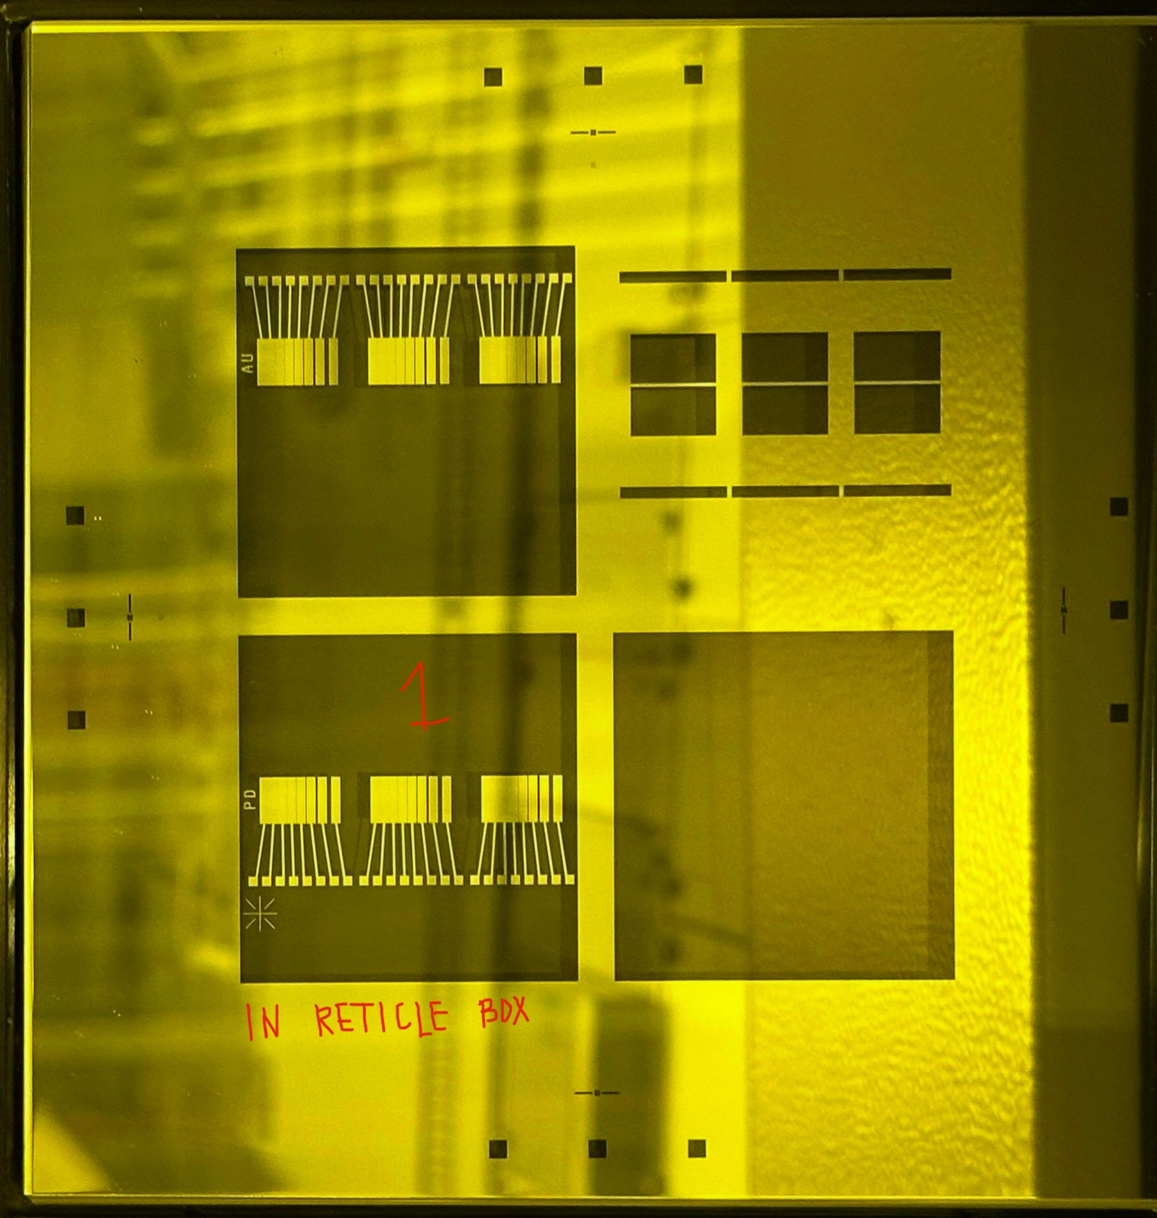

**Reticle loaded/aligned:**

During loading time, the reticle will be rotated 180 degrees, and automatically aligned to the system. See the picture bellow when the reticle is loaded and ready for exposure.

**Picture2 [Inside the system]**

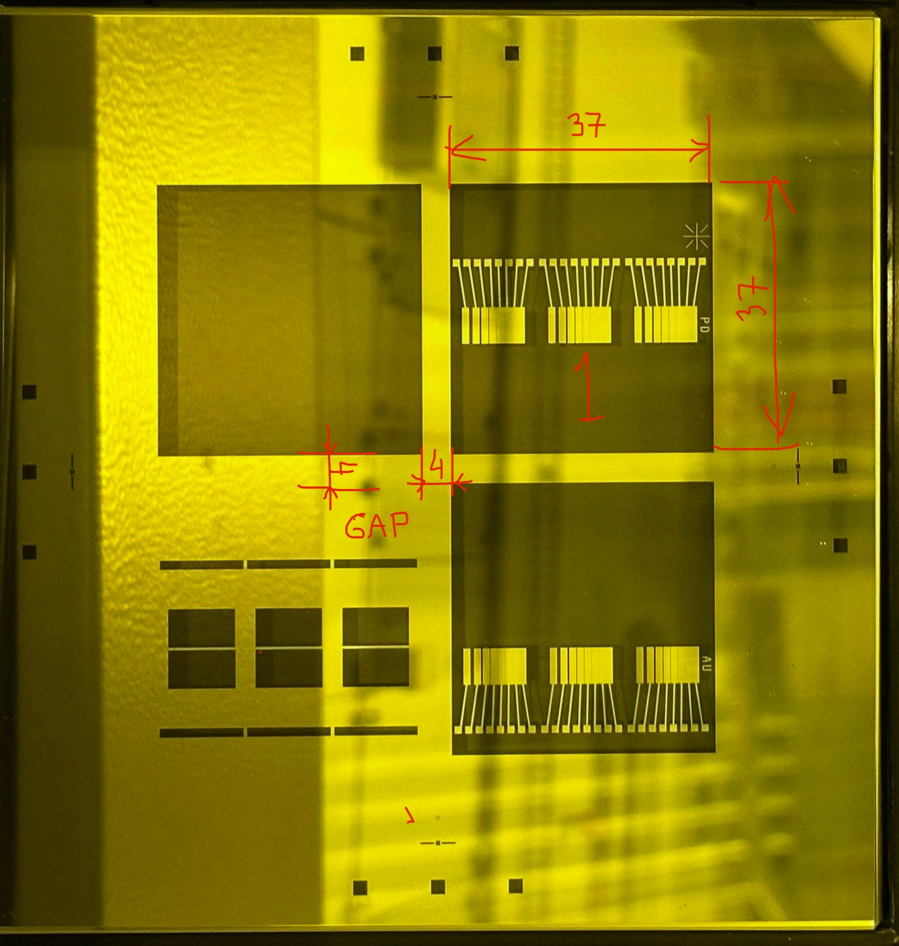

The **GAP between 4 layers** on this reticle is:

X1=4mm

Y1=4mm

**The Image size** of **layer #1** being exposed on the reticle is:

X2=37mm

Y2=37mm

**What is the PASS SHIFT?**

**Pass shift** is the distance from center of reticle to center of layer being exposed.

**How to calculate the pass shift?**

**A=X1/2=4/2=2**

**B=X2/2=37/2=18.5**

**PASS SHIFT** (on the reticle):

X=A+B=20.5mm

Y=A+B=20.5mm

**PASS SHIFT** (at wafer level, Stepper is 5X reduction):

**X=20.5/5=4.1mm**

**Y=20.5/5=4.1mm**

**Sign convention for pass shif**t (If layer#1 is in Upper Right Corner):

**X= +**

**Y= -**

**PASS SHIFT:**

**X= + 4.1mm**

**Y= - 4.1mm**

**WAFERS**: Using this pass shift with a programmed array (3x3) would center the array to the center of the wafer. You will have 9 exposures in the middle of the wafer.

**QUARTERS (or Pieces)**: Using this pass shift with a programmed array (3x3) would have the center of R3C1 exactly at the BL corner (**Picture 3** below).

**Picture3 [pattern shifted to the left and down]**

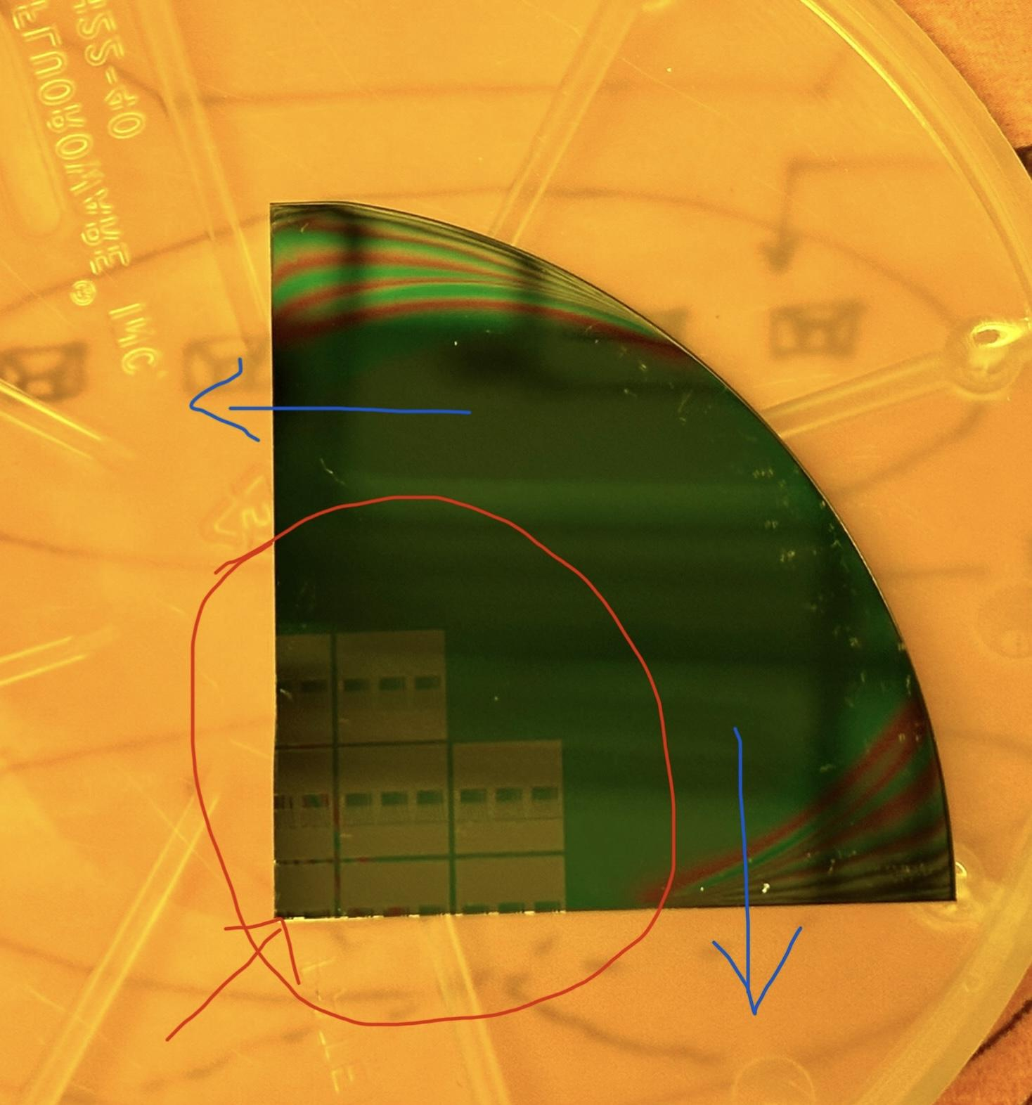

Since this is not ideal, the pattern needs to be shifted, so all exposures are on the quarter. The pattern needs to be moved up, and to the right. This means the stage needs to move to the left and down. Check the **Picture4** below for signs (keys: -x. +x, -y, +y).

**Picture 4 [ the keyboard signs/stage movemements]**

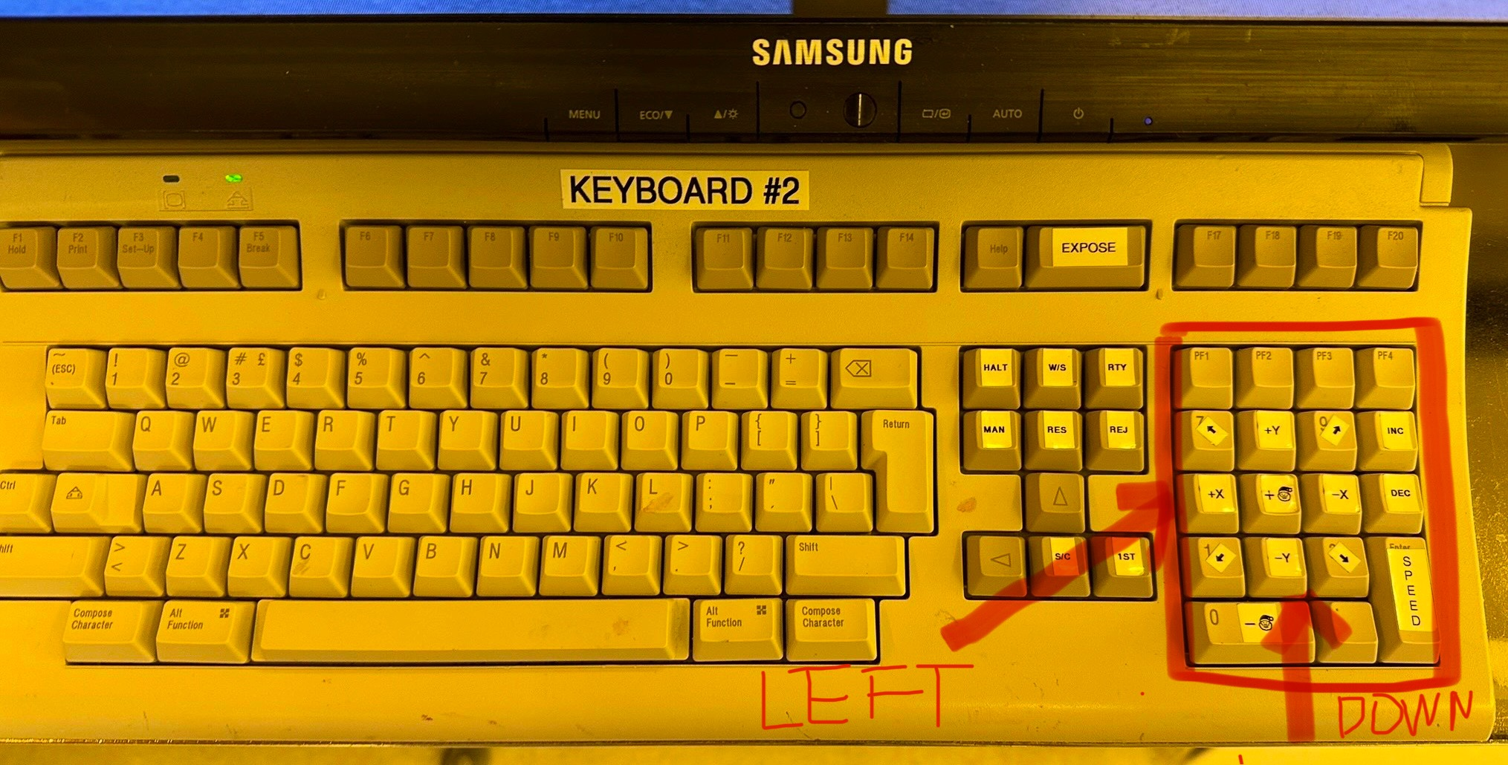

X direction: Moving the **stage to the left** requires pressing the key +X.

Y direction: Moving the **stage down** requires pressing the key -Y.

**(+X) —> you need to use addition**

**(-Y) —> you need to use subtraction**

We want to move for half die size (or half image size) in both directions, which is X=7.4/2=3.70mm, Y=7.4/2=3.70mm. Following the sign convention for stage movement where (+X) means adding, (-Y) means subtracting, the pass shift is calculated as following:

**PASS SHIFT:**

**X= +4.1 + (+3.70) = + 7.8000**

**Y=- 4.1 – (+3.70) = - 7.8000**

For the edge exclusion (moving the pattern from the edge in both x, y direction for 1mm), we need to adjust pass shift:

**PASS SHIFT:**

**X=+ 7.8000+1=+8.8000**

**Y= - 7.8000-1= -8.8000**

**EQUATION FOR PASS SHIFT: X=+8.8000, Y=-8.8000**

**RETICLE: Mask gap=4mm, Image size in X=37mm, Y=37mm**

**WAFER LEVEL: (dived by 5):**

**Mask gap=4/5=0.8mm, Image size in X=37/5=7.4mm, Y=37/5=7.4mm**

**Edge exclusion=1mm**

**A= Mask gap=4/5=0.8mm**

**B= Image size in X=37/5=7.4mm**

**C= Image size in Y=37/5=7.4mm**

**D= Edge exclusion=1mm**

**X= +(A+B)/2+B/2+D**

**X=+[(0.8+7.4)/2]+7.4/2+1= +8.8000**

**Y=-(A+C)/2-C/2-D**

**Y=-[(0.8+7.4)/2]-7.4/2-1= -8.8000**

**MASKING APERTURE SETTING:**

**XL: 50**

**XR:10**

**YF: 50**

**YR: 10**

The blade apertures settings will determine which side of the reticle will be exposed. I am exposing the upper right corner, so everything else needs to be covered except this corner. Please check your reticle design to determine blade aperture settings correctly.

**A-RRAY OR P-LUG: A**

A- means array, P- means plug. In this job is selected “A” for array. If you want to expose only one day you could select “P” and enter info about Row and Column of die to be exposed.

**DROPOUTS:**

If you want to drop some dies, you need to enter at the prompt sign for R-row you are dropping, for C-column you are dripping. I dropped R1, C3, so I entered for R=1, for C=3

**QUARTERS (or Pieces) with BL orientation**: Using the correct pass shift would have the pattern 1mm away from (**Picture 5** below).

**Picture5 [pattern at the right position]**

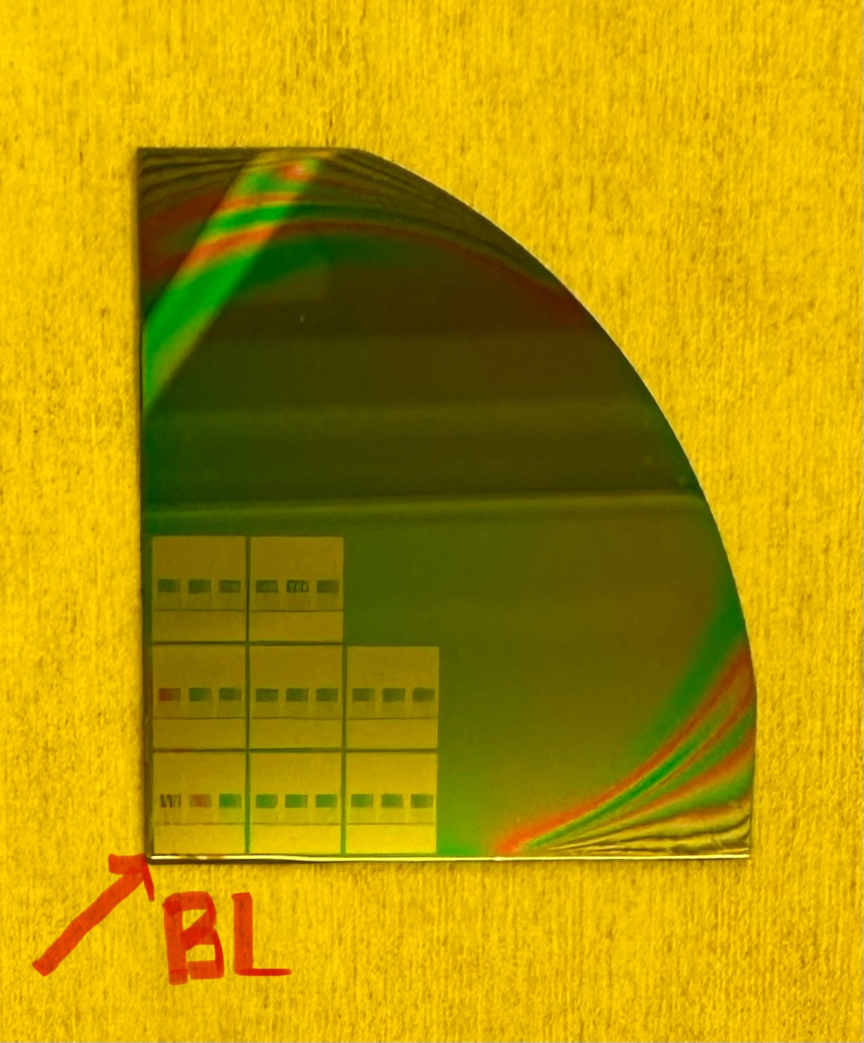

**Running the job QBL8 on Autostep 200:**

Before you start, make sure you know the exact thickness of your substrate!

1. **LOG IN to your account (my account is [10,151])**
2. Type **CHUCK**, and select 142 for (one quarter of 2 inch)
3. **EDIT** the job, make sure all parameters are correct
4. **Choosing correct chuck** for substrate loading (for this job it is used chuck labeled as **2”/500um**)

* Check the chuck (all screws on front/back side need to be tight, shim (no for this job))

IMPORTANT:

* TARGET Thickness (Chuck Thickness+Substrate thickness): 12.15+/-0.1mm.
* Follow the “Target Thickness Rule” to check if you need shim or not
* Good (your sample thickness is within this range (+/-100)um of the thickness indicated on the chuck (500um))
* Add shim (your sample is too thin)
* Change chuck (your sample is too thick)

1. **Loading Substrate on the chuck**

* Make sure your sample is clean from the back side (no PR rings or particles). Load the substrate on the chuck with 90degree angle at the lower left corner. Position your sample in the middle of chuck. Turn on the knob for “Chuck Vacuum ON” located on the left side from the stage.

1. **Loading Chuck with substrate on the stage**

* Load the chuck carefully on the stage. Do not hit objectives. Turn on the knob for “Stage Vacuum” located on the left side from the stage.

1. **Loading Reticle**

* Follow instructions to load reticle in the reticle box. Use command RMSL to load reticle in the elevator. You can use any slot from 2-9.

1. Type: **EX QBL8\1**

* Exposure time=0.39sec, focus=0
* Go through options given on the Stepper: Enter reticle bar code (My reticle does not have a bar code, so I typed NONE), Floor number (I loaded reticle in slot #3), alignment mark phase (type N). When it says “Start AWH”- press MAN on the keyboard, and then press MAN again). Wait for the stage to stop moving.

1. **BL orientation substrates IMPORTANT**

**Press “A” on the keyboard**

* Before you start aligning your substrate with BL orientation, you need to press “A” on the keyboard. This will move the stage, and the left objective will be closer to the lower left corner of the substrate (left objective = R3C1, right objective=R3C3).
* If the “translate origin” values are close enough, the left objective will be near the BL corner. If not, you need to use keys (+x, -x, -y, +y) on the keyboard and move around to find the BL corner.

1. **Aligning substrate**

* After **finding BL corner**, position the cross hair (left objective, left monitor) in the middle of substrate edge
* Press “D” on the keyboard, followed by key (+X)

The stage will move to the left for one die size (in this case 7.4mm). Check if you see the edge of your substrate. If yes, note if it is up or down. Press (+X) again and continue checking the position of substrate edge relative to cross hair on left objective. Be careful in pressing the key (+X). If you step from the sample you need to start all over your job. Recommended to press key (+X) as many times as you have dies on your substrates (in this job 3 dies in x direction). If you do not see the edge while pressing key (+X) or it is too far, but you know it is up or down, do the following:

* Press key (-X) as many times as needed to go back to BL left corner
* Press “E” on the keyboard to exit from “D” mode
* **Aligning along the substrate edge**, there are two options:

1. MANUAL Alignment:

Turn off the stage vacuum knob (located on the left side from stage), and manually move the chuck in one or other direction. Turn the stage vacuum back on. Continue alignment, trying to get the edge of substrate straight. You might need to repeat this several times, until you can see the edge every time you press (+X) on the keyboard.

1. FINE Alignment:

Use the keys on the keyboard for rotation (+θ or -θ) and do fine alignment. The goal is to see the substrate edge in the middle of the crosshair of the left objective.

* Once alignment in X direction looks good, check alignment in Y direction. It should be good if the alignment in X direction was done well.
* Make sure you are back to the BL corner of your substrate
* See the **Pictures 6/7 below** after alignment is complete in both directions

**Picture 6 [alignment in x direction]**

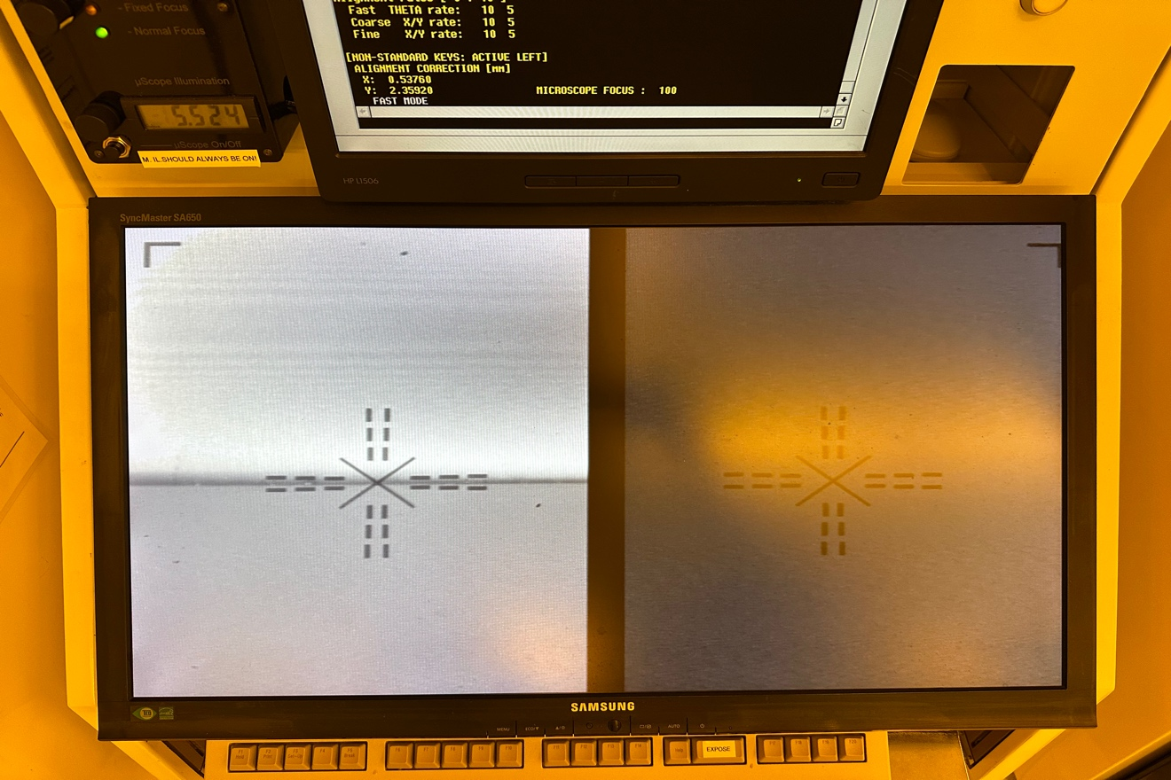

**Picture7 [alignment in y direction]**

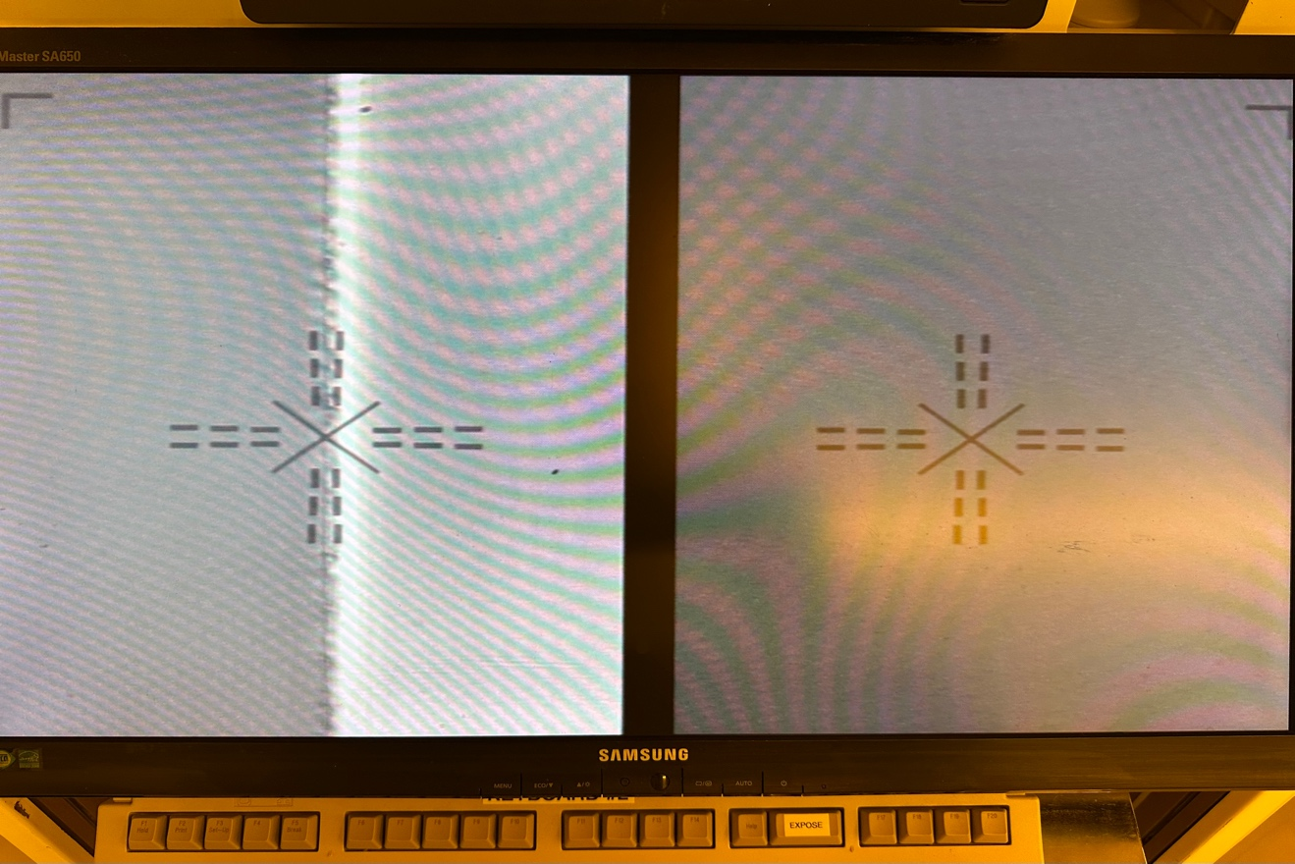

**9. Exposure**

* Pressthe key “EXPOSE” on keyboard
* Wait for the stepper to complete exposures

**10. Unloading the substrate**

* Turn off stage vacuum, unload the chuck
* Turn off the substrate vacuum, unload the substrate

**11. Unload Reticle**

* Use commands RMSR, followed by RMSL
* Unload the reticle

**12. LOG OUT**

**13. LOG BOOK**

* Enter in the info about your run, and if you had any issues
* if yes, report it to Nanofab

**14. COMPLETING** the job

* Do PEB (post exposure bake-if needed), develop, and microscope inspection
* Make necessary changes, if needed. If not continue with other samples