Verify that the stage is in the Load position (See Fig. 1). Place your tape ring on the stage. Slide the ring underneath the two black tabs and ensure that it is sitting flush on the bottom bezel of the stage. Rotate the retaining lever so that it securesthe tape ring.

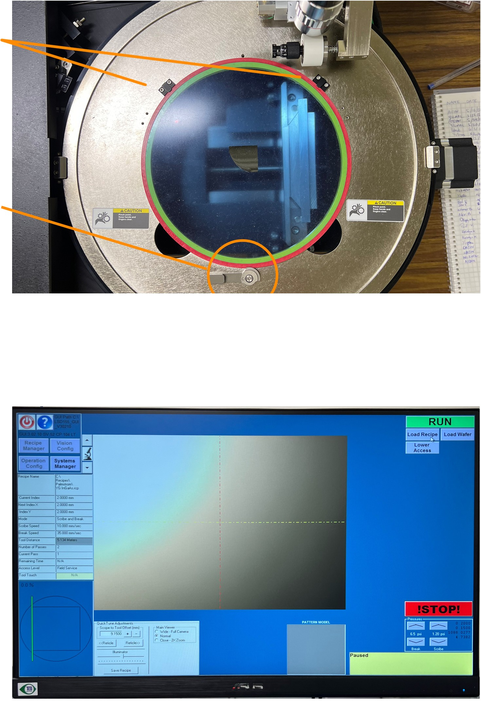
Black tabs

Retaining lever

Fig. 1

Click Load Wafer (See Fig. 2). Watch your hands! The stage will clamp down and the camera will move onto the tape. Click Load recipe and select your recipe.

Fig. 2

Use the arrow buttons along the X and Y axis to navigate to a feature that you can align to. The greater the number of arrows the faster you can move across your sample. Note: Movement in the X direction is inverted. To move left click a right arrow button and vice versa.
To do a quick alignment, right-click and drag across the edge of a feature. This will pop a window asking if you would like to move the theta stage. Click OK and the feature will be aligned.

For a more accurate alignment, click on Two Point Theta Adj on the upper right portion of the software (see Fig. 4P). Move to a feature you can align to. This can be either horizontally or vertically. Click on the feature. Next, move to another feature in the same row and click on it. After clicking Ok the stage should rotate to satisfy the alignment. The dialogue box on the bottom right of the software will guide you through the Two Point Theta Adj process.

After loading your sample click on the ‘Change Tool’ button on the uper right portion of the screen. See Fig. 3.

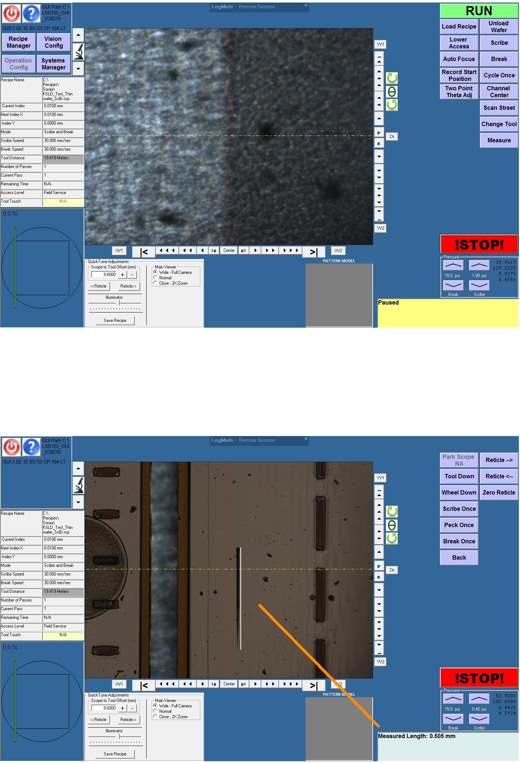
Fig. 3.
This will move the diamond scribe to a safe place on the stage. Move the camera to a safe portion of your sample or dummy sample. If you have a dummy sample loaded next to your sample make sure both sample thicknesses are the same. Click the ‘Peck Once’ button in the top right portion of the screen. See Fig. 4.

Fig. 4.
Once the peck has been made, measure the length by right clicking and dragging all the way across the peck. If a dialog box pops up click ‘Cancel’. The length of the peck will be displayed in the lower right box on the screen. The appropriate length is somewhere betwen 200-250um. If your peck mark is too long, turn the vertical micrometer above the scribe clockwise (see Fig. 5.). Each tick mark on the micrometer is 2 um.

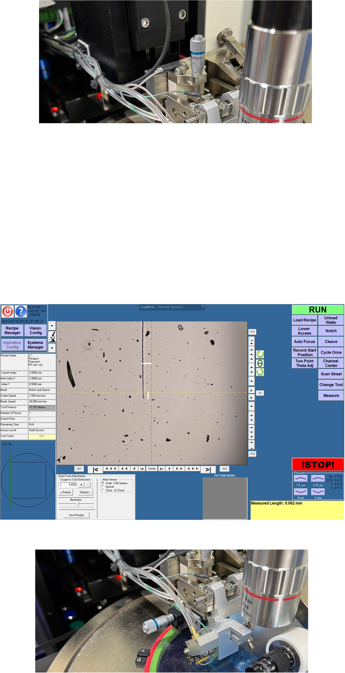

Fig. 5.

X alignment correction: In order to move the vertical reticle line over the notch you must use the small micrometer next to the microscope objective (see Fig. 5). To move the reticle to the left you will rotate the micrometer clockwise. To move it to the right you will move the micrometer counterclockwise. Every tick mark on the micrometer equals two microns. Right-click and drag from the center of the notch to the vertical reticle line. Note: If prompted to click Ok, press cancel. Clicking Ok will adjust the theta angle. The measured distance will be displayed in the lower right dialogue box. Rotate the micrometer the right amount of tick marks to satisfy that distance.

Y alignment correction: The notch should start at the middle of the reticle cross hair and move up. If the notch is too far above or below the horizontal reticle, right click and drag from the bottom of the notch to the center of the crosshair. The measured value will be displayed in the bottom right dialogue box. Click cancel if a window pops up. Add the measured value to the Scope to Tool Offset (see Fig. 4).

Fig. 6.

Fig. 6.

